OPTION 1

Click on the folder list button at the bottom of the screen

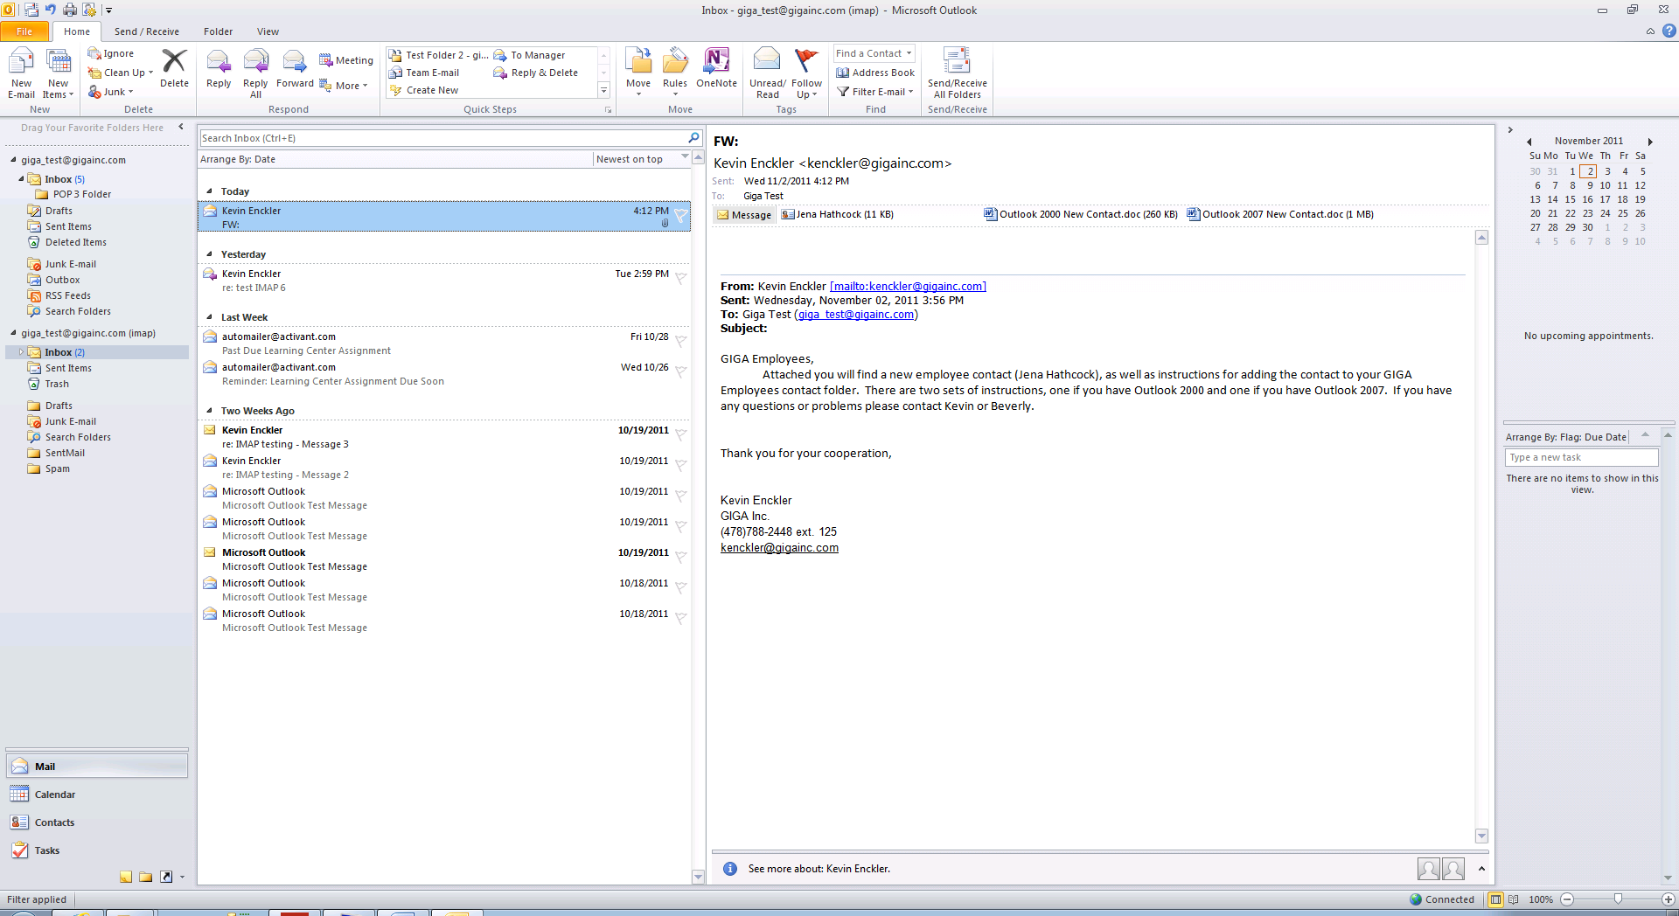

This will give you the ability to see the GIGA Employees contact folder.

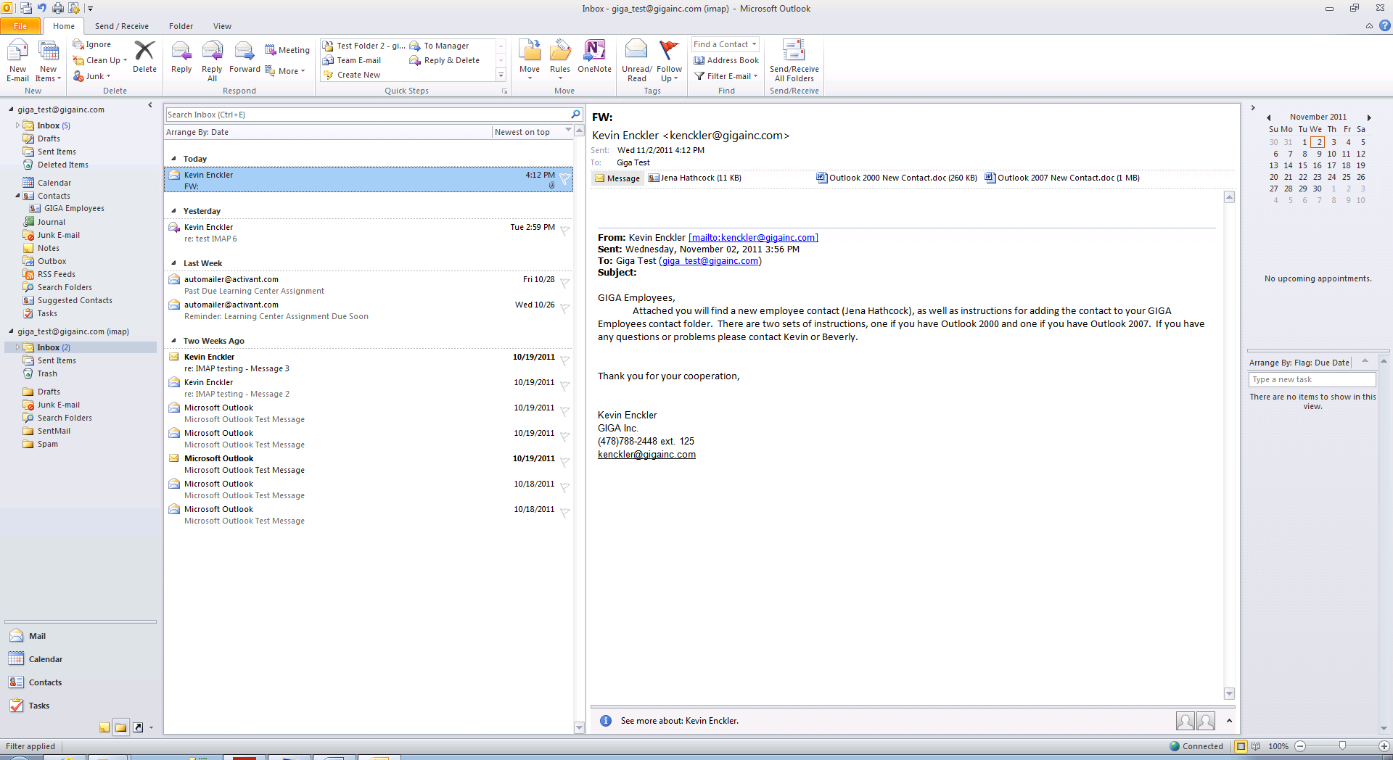

You can then click and drag the contact attachment to your GIGA Employees folder. This will copy the new contact to your GIGA Employees folder.



OPTION 2

Another way to do this is to double click on the Contact attachment

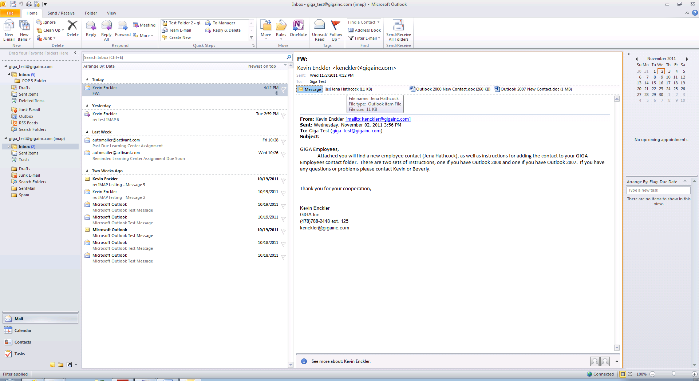

This will open the contact information, when the contact information opens, click File

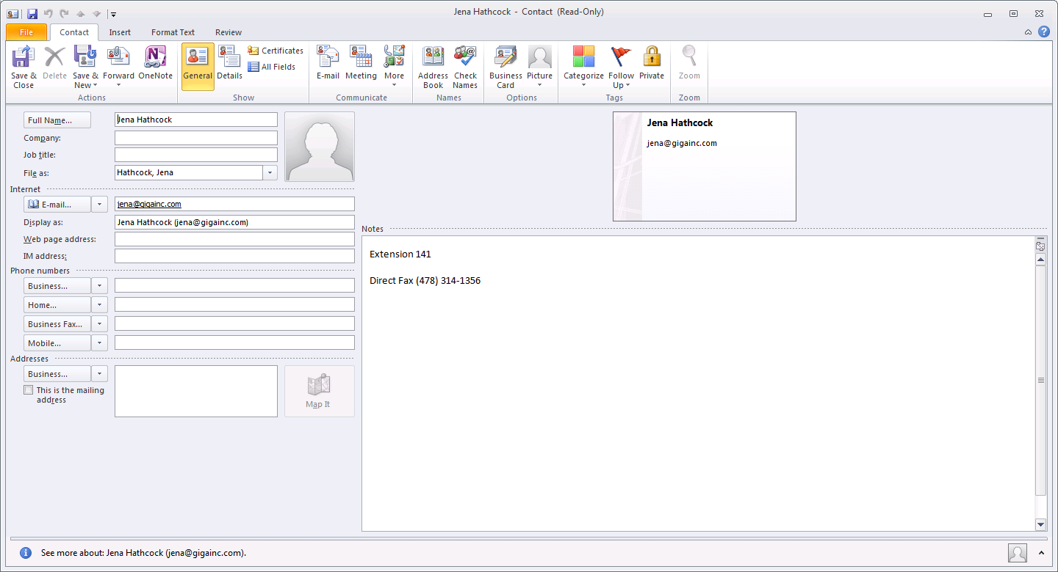

Then select move to folder and then select the copy to folder option.

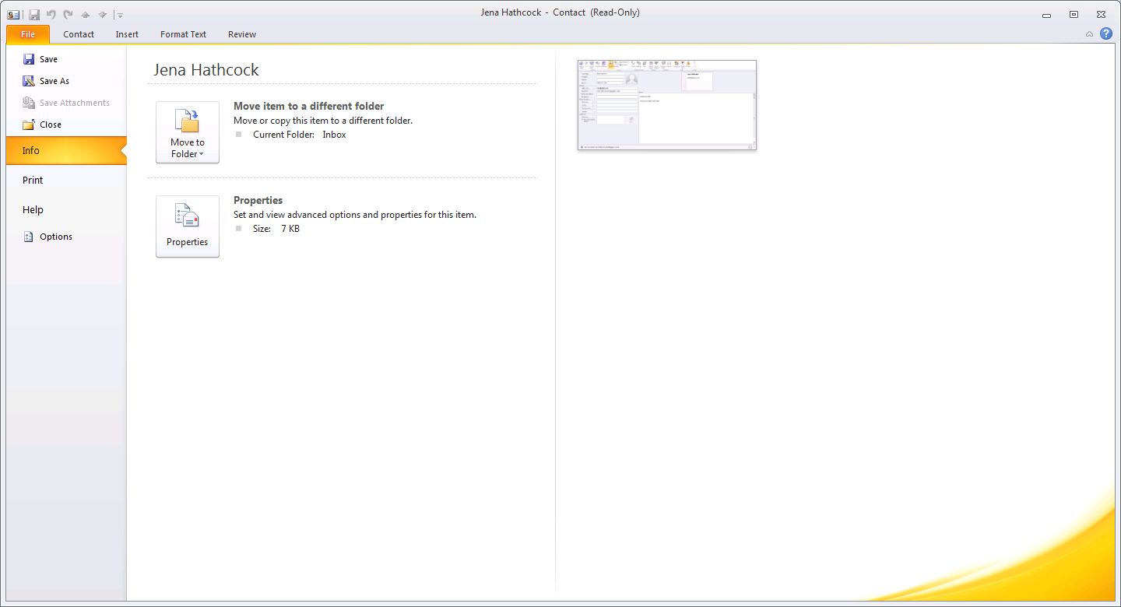

You will then be able to select the GIGA Employees contact folder and press OK.

